Designing a Fuel-efficient Automobile: A Multiple Linear Regression Analysis
Allen Gao
University of Massachusetts Amherst
MIE622
Michael Prokle
Introduction
A manufacturer known for producing large automobiles needed assistance in designing an energy-efficient car. To address this problem, a multiple linear regression model was used to determine which vehicle attributes were associated with higher miles per gallon (MPG) and how accurately MPG could be predicted. A dataset with attributes cylinder, displacement, horsepower, weight, acceleration, model year, and US manufacturing status was given to help us determine which of these attributes would contribute most to MPG, to help tell the manufacturer to focus on those attributes to help design a more fuel-efficient automobile.
Data Cleansing
Before cleaning the loaded dataset, it was first inspected to identify its structure, data types, missing values, and duplicate observations. After the initial inspection, the column names were standardized by removing unnecessary spaces, converting them to lowercase, and replacing internal spaces with underscores. This made the column names easier to reference consistently throughout the analysis. The inspection identified that there were 6 missing values in the horsepower variable, which were represented by question marks rather than recognized null values. The dataset was also checked for exact duplicate observations because repeated records could have an unnecessary influence on the regression model. No exact duplicates were found, so no observations were removed for this reason. The question marks were converted to NaN so that Python could recognize them as missing observations. Before replacing those recognized null values with actual values, the horsepower variable had to be changed from an object data type to a numeric data type. Pandas had originally classified the column as an object, probably due to it containing question marks that were mixed with numerical horsepower values, which caused it to be viewed as an object data type.
Once the horsepower variable column had question marks replaced with recognized null values and changed to a numeric data type, median imputation was used to replace the six missing values. The median was selected instead of the mean because it is less affected by unusually high horsepower measurements. This approach also preserved the other valid information contained in those observations rather than removing the entire rows. The us_made variable was considered for removal because the manufacturing location is not a physical vehicle characteristic. However, it was retained as a binary predictor because it could represent differences in vehicle design or production practice associated with MPG.
Building the Linear Regression Model
Before building the model, MPG was selected as the dependent variable because the goal was to predict gas mileage and determine which vehicle attributes were associated with higher fuel efficiency. Cylinders, displacement, horsepower, weight, acceleration, model year, and U.S. manufacturing status were treated as the independent predictor variables to determine which of them had statistically significant relationships with MPG. The data were then divided into training and testing sets, with 70% of the observations assigned to the training set and the remaining 30% assigned to the testing set. The training set was used to estimate the regression model, while the testing set was used to evaluate its performance on previously unseen vehicles. A random state of 42 was used to make the split reproducible.
Once the dataset is all split up, the training predictor has a column of constants that was added to it. The ordinary least squares (OLS) linear regression model was fitted using the training MPG values as the dependent variable and the training vehicle attributes, along with an added constant term, as the independent variables. After the model was fitted, its summary can be printed to check the training R², the significance of each predictor to the model, and the coefficient of them.
Once the model was trained using the training data, it was applied to the testing predictors to generate predicted MPG values for previously unseen vehicles. A constant term was first added to the testing predictors so that they had the same structure as the predictors used to train the model, because the model doesn’t automatically add the intercept, which, without it, would distort the model. Once the constant is added, the trained regression model is used on the testing data to predict the MPG. The predicted MPG values were then compared with the actual testing MPG values to calculate the R² and RMSE. The test R² measured the model’s predictive performance by showing the proportion of MPG variation explained by the model, while RMSE measured the typical size of the prediction errors in MPG.
After getting the test data’s R² and RMSE to check how accurate, the model is then optimized using backward stepwise selection to simplify the model and determine whether removing nonsignificant predictors could improve its performance. The backward-selection procedure was created as a function that accepted the training predictors and training MPG values. It also included an alpha value of .05, which served as the threshold for determining statistical significance. The function began with all predictors, and a constant term was added so that each OLS regression model could estimate an intercept rather than being forced through the origin. During each iteration, an OLS model was fitted using the remaining predictors, and their p-values were examined. The predictor with the highest p-value was removed when its p-value exceeded .05. The model was then refitted, and the process continued until all remaining predictors were statistically significant. Once the function was completed, it was applied to the training predictors and their corresponding training MPG values. The function returned the predictors retained by backward selection and the final optimized OLS regression model.
Once the model was optimized by removing nonsignificant predictors, it was evaluated using the testing data. Only the predictors retained through backward selection were selected from the testing set, and a constant term was added so that the test data matched the structure expected by the optimized model. The model then generated predicted MPG values, which were compared with the actual testing MPG values to calculate its test R² and RMSE. To visually compare the original and optimized models, actual-versus-predicted MPG diagrams with fitted trend lines were created using the test data. These diagrams helped determine whether there were noticeable differences in the models’ prediction patterns and performance.
Results
Once the modeling process was completed, the original model was able to reasonably accurately predict MPG based on the attributes of the vehicle. The training data was able to have an R² score of 0.815, whereas the testing R² is 0.840. The testing RMSE was 3.031, which indicates that the model’s prediction typically differed from the actual test MPG values by 3.031. The near-similar training and testing R² values, along with the relatively low RMSE, showed that the model generalized well to previously unseen vehicles and did not display clear evidence of overfitting. Of the model, the attributes that were significant with a p-value less than 0.05 were the weight of the car, US Manufacturing status, and the model year.
As shown in Figures A1 and A2, weight had a negative coefficient in both the original and optimized regression models, indicating that heavier vehicles were associated with lower MPG. Therefore, reducing vehicle weight could help increase gas mileage because heavier vehicles generally require more energy to accelerate and maintain motion. The manufacturer should consider using lighter materials and removing any unnecessary vehicle mass when designing a more fuel-efficient automobile. Another significant attribute was U.S. manufacturing status, which had a negative coefficient in both the original and optimized regression models. Because a US-made vehicle is coded as 1 and a non-US-made vehicle is coded as 0, the negative coefficient indicates that US-made vehicles are associated with lower MPG. The manufacturing location isn’t a physical design and should not be interpreted as a direct cause of lower fuel efficiency. Instead, the variable may reflect differences in the technologies, vehicle designs, and production practices used by non-U.S. manufacturers. However, the dataset does not provide enough information to determine which specific differences caused the MPG relationship. The manufacturer that requested assistance with designing a more fuel-efficient automobile should examine the technologies, vehicle designs, and production practices used by the more efficient non-U.S.-made vehicles in the dataset. The last significant attribute is the model year, which has the only positive coefficient among the other two significant attributes. It has a coefficient of approximately 0.81, where an additional model year would increase the MPG by 0.81. The model year may have reflected the improvements in engine technology, emissions, and aerodynamics over time. As the model year isn’t a physical design, the manufacturer should focus on adopting the newer technologies represented by later model years to make the automobile more fuel-efficient.
As shown in Figure A2, after backward stepwise selection was completed, the optimized model was fitted using the training data and achieved a training R² of 0.813. The model retained weight, model year, and U.S. manufacturing status because they remained statistically significant after the other predictors were removed. Once the selection was completed, the model was then evaluated with the test dataset. It achieved a test R² of 0.833 and an RMSE of 3.093. Compared with the original model’s test R² of 0.840 and RMSE of 3.031, the optimized model performed slightly worse but provided a simpler model with fewer predictors that did about the same as well. The optimized model was able to reasonably achieve the goal of accurately predicting MPG with just the most significant predictor, as the original model’s test R² is extremely close to the optimized model’s test R², as they are only about .007 part. As shown in Figures A3 and A4, actual test MPG was plotted on the horizontal axis, while the MPG predicted by each model was plotted on the vertical axis. The fitted trend line summarizes the linear relationship between the actual and predicted values. Most observations in both plots were located relatively close to their trend lines, indicating similar prediction patterns. As the regression result shown in A2, the us_made variable would have contributed to higher MPG than others, as non-US-made vehicles would have increased the MPG by about 2.58 in the optimized model. It may have a higher coefficient due to it being only a binary predictor, unlike the rest of the predictors, so the coefficient alone could not be used to conclude that U.S. manufacturing status contributed more to MPG than weight or model year.
Overall, the multiple linear regression was able to predict the MPG reasonably well, even with the optimized model that uses the significant predictors only, which it picked from the backward stepwise selection, with an R² of about .840 and .833 respectively, which shows the accuracy of the model. Based on the results, the manufacturer should focus on examining the technologies and production practices used by more efficient non-U.S. manufacturers, reducing vehicle weight, and adopting the latest improvements in engine efficiency to achieve a more fuel-efficient automobile. The linear regression is a useful tool to help find which attributes would contribute more to the target variable, which can help people select which to prioritize.

Appendix
Figure A1
OLS Regression Result for Original Model
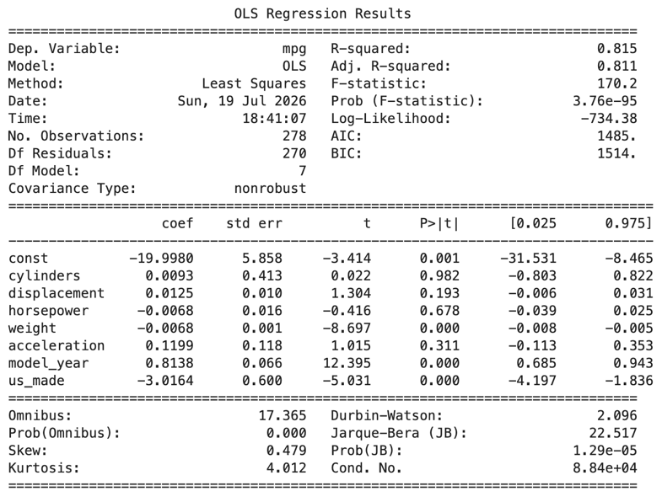
Note: Figure A1 is the regression model that wasn’t optimized by the backward stepwise selection yet, with the R² and all of the predictors with their coefficients
Figure A2
OLS Regression Result for Optimized Model
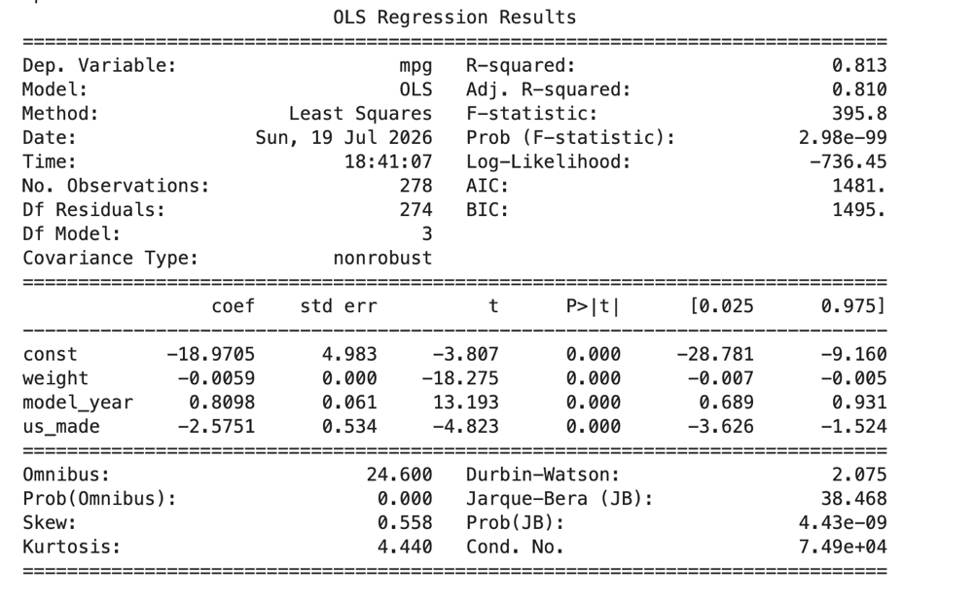
Note: Figure A2 is the regression model that was optimized by the backward stepwise selection, where only the significant predictors that had a p-value less than 0.05 were left.
Figure A3
Actual versus Predicted MPG Original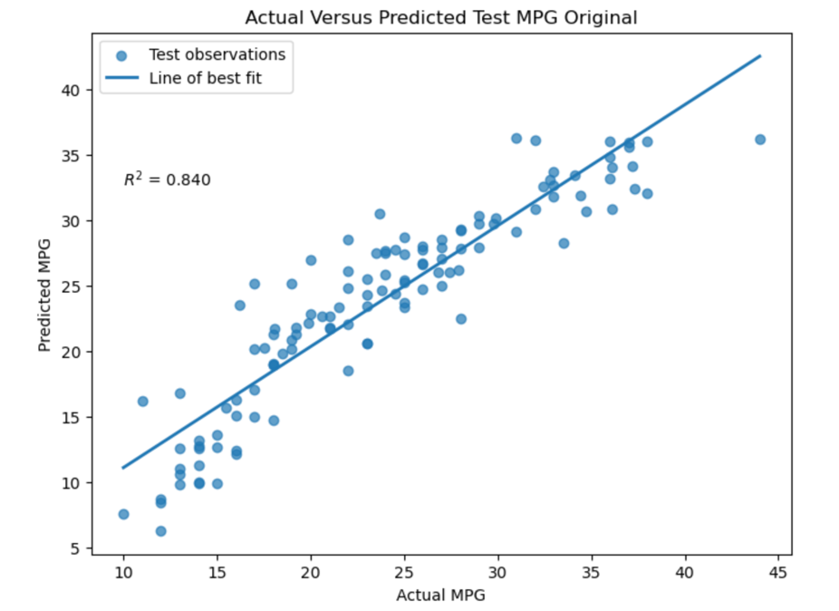
Note: Figure A3 is the best fit diagram, which has Actual versus Predicted MPG. Most of the observations are quite close to the line of best fit in the original model using the test data.
Figure A4
Actual versus Predicted MPG Optimized
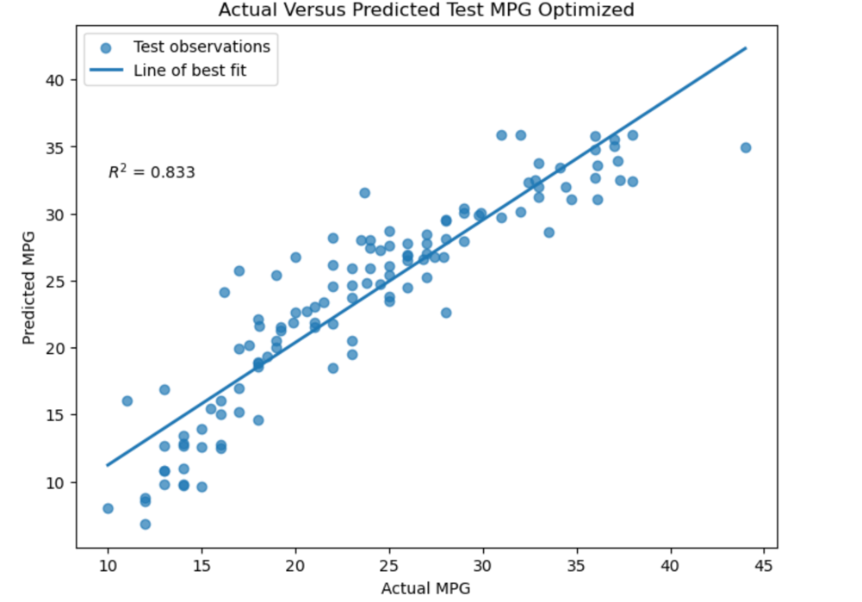
Note: Figure A4 is also a best fit diagram as well with the same Actual versus Predicted MPG. It is a lot like the original model, where most of the observations are close to the line of best fit for the optimized model when using the test data.

